Information extraction from blood glucose data

Self-monitoring of blood glucose can provide large amounts of data which might be hard to interpret both for patients and health professionals. Automated data processing can add valuable information to the interpretation of the data. Pattern management is a systematic approach to help patients and health care providers to identify patterns in blood glucose readings to determine whether changes are needed to optimize their glucose control.
The prototype developed by ALL within the REACTION project implements the pattern management approach, i.e. it extracts meaningful patterns from the monitoring data. In addition it is able to provide generic advices related to the identified patterns.

Guide to the prototype user interface
On the first page, the user can specify the input parameters:
- patient id (mandatory)
- start date and end date (optional): time interval for the analysis, last 14 days will be processed if not specified
- advice: specifies what kind of advices should be returned (options: 0=no advice, 1=advice to patient, 2=advice to health professional)
The results can be retrieved by clicking on the “Show patterns” button.
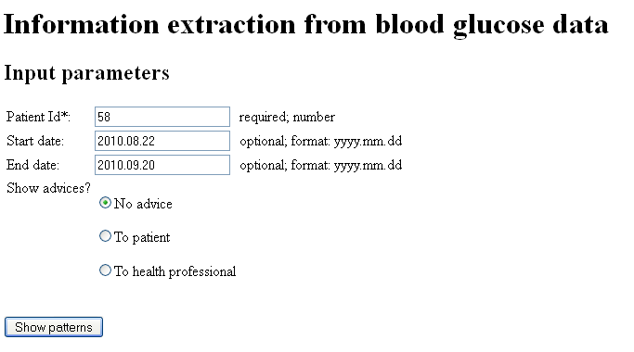
Figure 1: Input form

If the patient id field is blank, or not a valid number is given, the page displays an error message.
If any of the two date fields is blank, the module analyses the last 14 days. If two valid dates are specified, the measurements between these dates are processed. Otherwise an error message is displayed.

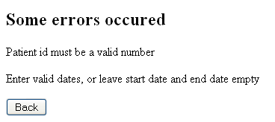
Figure 2: Error page

If no error was found, the results page is displayed. It contains the following elements:
- Patient id
- The analysed time period
- Visualization of the blood glucose values: the table’s rows show times of the day (morning, noon, afternoon, evening, night), the columns are individual days. If no measurement was taken in a given time slot, the cell is grey. Otherwise the value is shown and colour coded (yellow: low, green: normal, red: high). The tooltip of a cell shows the exact time of the measurement. (Note: if multiple measurements were performed in a time slot, only one value is presented, and an * is added to the cell.)
- List of identified patterns, grouped by type. Additional information like time period, number of events or value is displayed.
- Advice to each type of patterns, if input was not 0

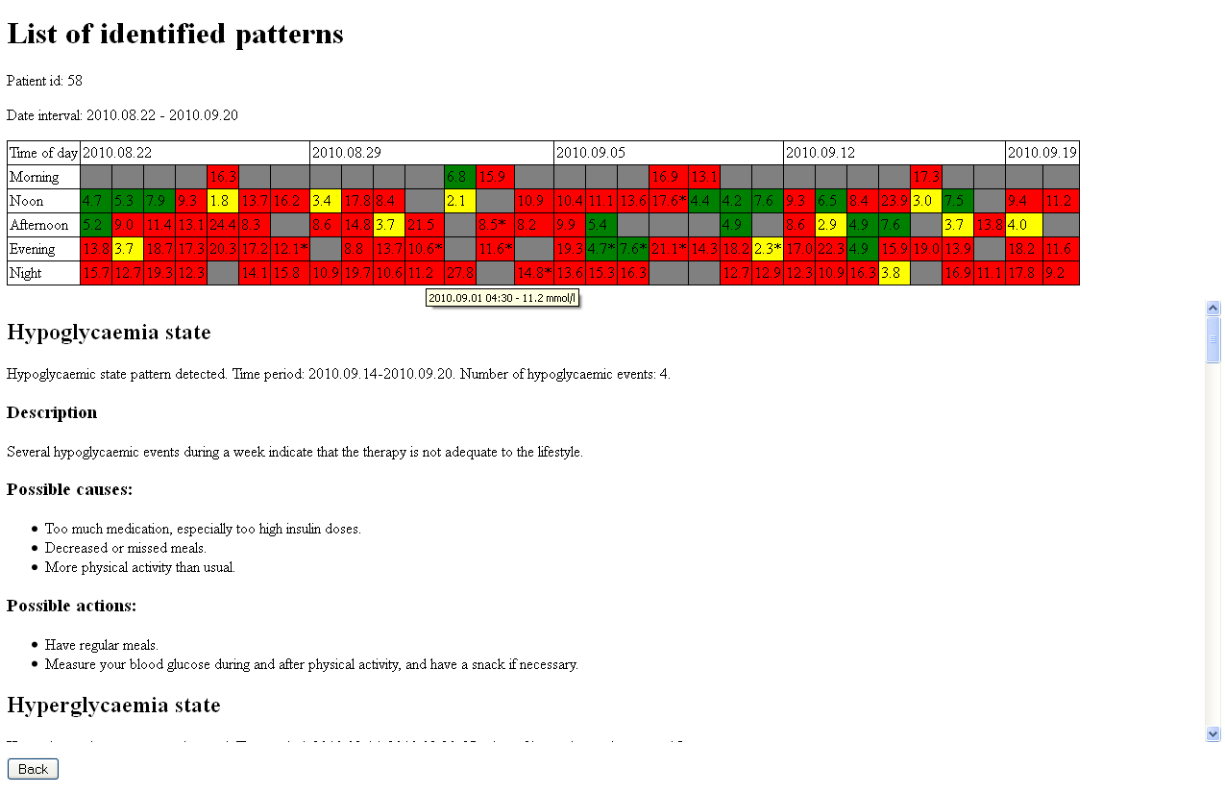
Figure 3: Result page
The advices consist of the following elements:
- short description and meaning of the problem
- list of possible causes
- list of potential actions (advices) – the user might get different advices based on his role (i.e. patient or clinician)

List of patterns
The prototype application looks for the pattern types listed in the table below.
Pattern name | Definition
Hypoglycaemic state | The number of hypoglycaemic events in any 7-day time period exceeds the defined threshold.
Hyperglycaemic state | The number of hyperglycaemic events in any 7-day time period exceeds the defined threshold.
Oscillating state | The number of both hypo- and hyperglycaemic events exceed a threshold in any 7-day time period.
Dawn phenomenon | Fasting hyperglycaemia with no hypoglycaemia in the previous 12 hours
“Somogyi effect” (Rebound hyperglycaemia) | Hypoglycaemic event followed by a hyperglycaemia within 12 hours. Most commonly occurs as hypoglycaemia at night and hyperglycaemia in the morning.
Morning hyperglycaemia | Fasting hyperglycaemia and no measurement available from the previous 12 hours. (It can be caused by either dawn phenomenon or Somogyi effect.)
Excessive postprandial excursion | The difference between a preprandial and the consecutive postprandial reading is above a threshold.
Excessive excursions between meals | The difference (increase or decrease) between two consecutive preprandial values is above a threshold.
Hypoglycaemia at a specific time of day | The number of hypoglycaemic events exceeds a threshold or the average blood glucose is below a threshold at a specific time of day (morning, noon, afternoon, evening, night) in any 7-day time period.
Hyperglycaemia at a specific time of day | The number of hyperglycaemic events exceeds a threshold or the average blood glucose is over a threshold at a specific time of day (morning, noon, afternoon, evening, night) in any 7-day time period.

Summary
This component might be a useful tool to support both patients and health professionals in understanding the results of self-monitoring of blood glucose. While single out-of-target measurements occur every now and then, patterns existing over several days may indicate that the patient’s treatment is not ideal or it is not properly aligned to his/her lifestyle. Pattern analysis could help to identify the situations where some intervention is necessary.

Contact:
Applied Logic Laboratory
Hankoczy u. 7.
H-1022 Budapest
Hungary
Email: info@all.hu

The information in this document is subject to change without notice. The Members of the REACTION Consortium make no warranty of any kind with regard to this document, including, but not limited to, the implied warranties of merchantability and fitness for a particular purpose. The Members of the REACTION Consortium shall not be held liable for errors contained herein or direct, indirect, special, incidental or consequential damages in connection with the furnishing, performance, or use of this material.
Possible inaccuracies of information are under the responsibility of the project. This report reflects solely the views of its authors. The European Commission is not liable for any use that may be made of the information contained therein. Copyright 2012 by the REACTION project.
The REACTION project is partly funded by the European Commission under the 7th Framework Programme in the area of Personal Health Systems under Grant Agreement No. 248590.





